WEEK 0 FLOW CHARTS AND ALGORITHM
ROLL NO.:241801266
NAME: SHYAM GANESH D
PROGRAM 01
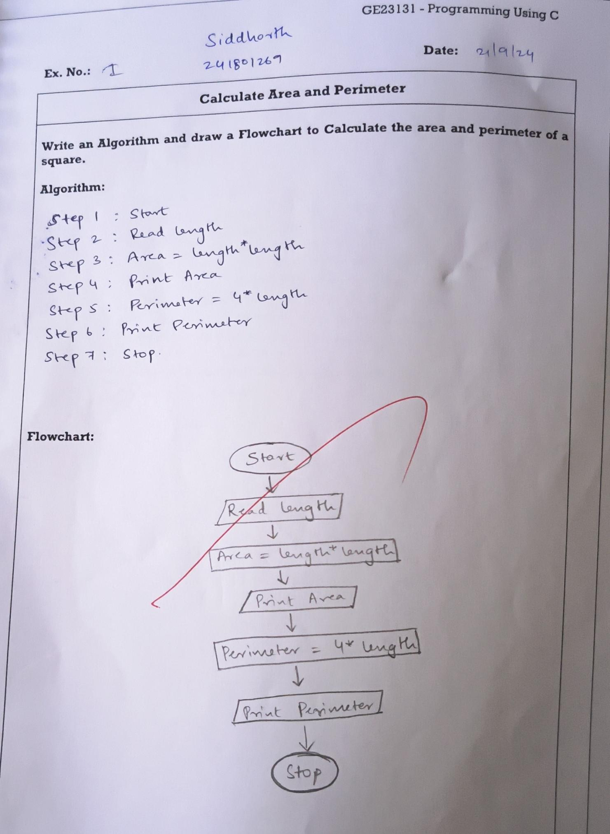
PROGRAM 02
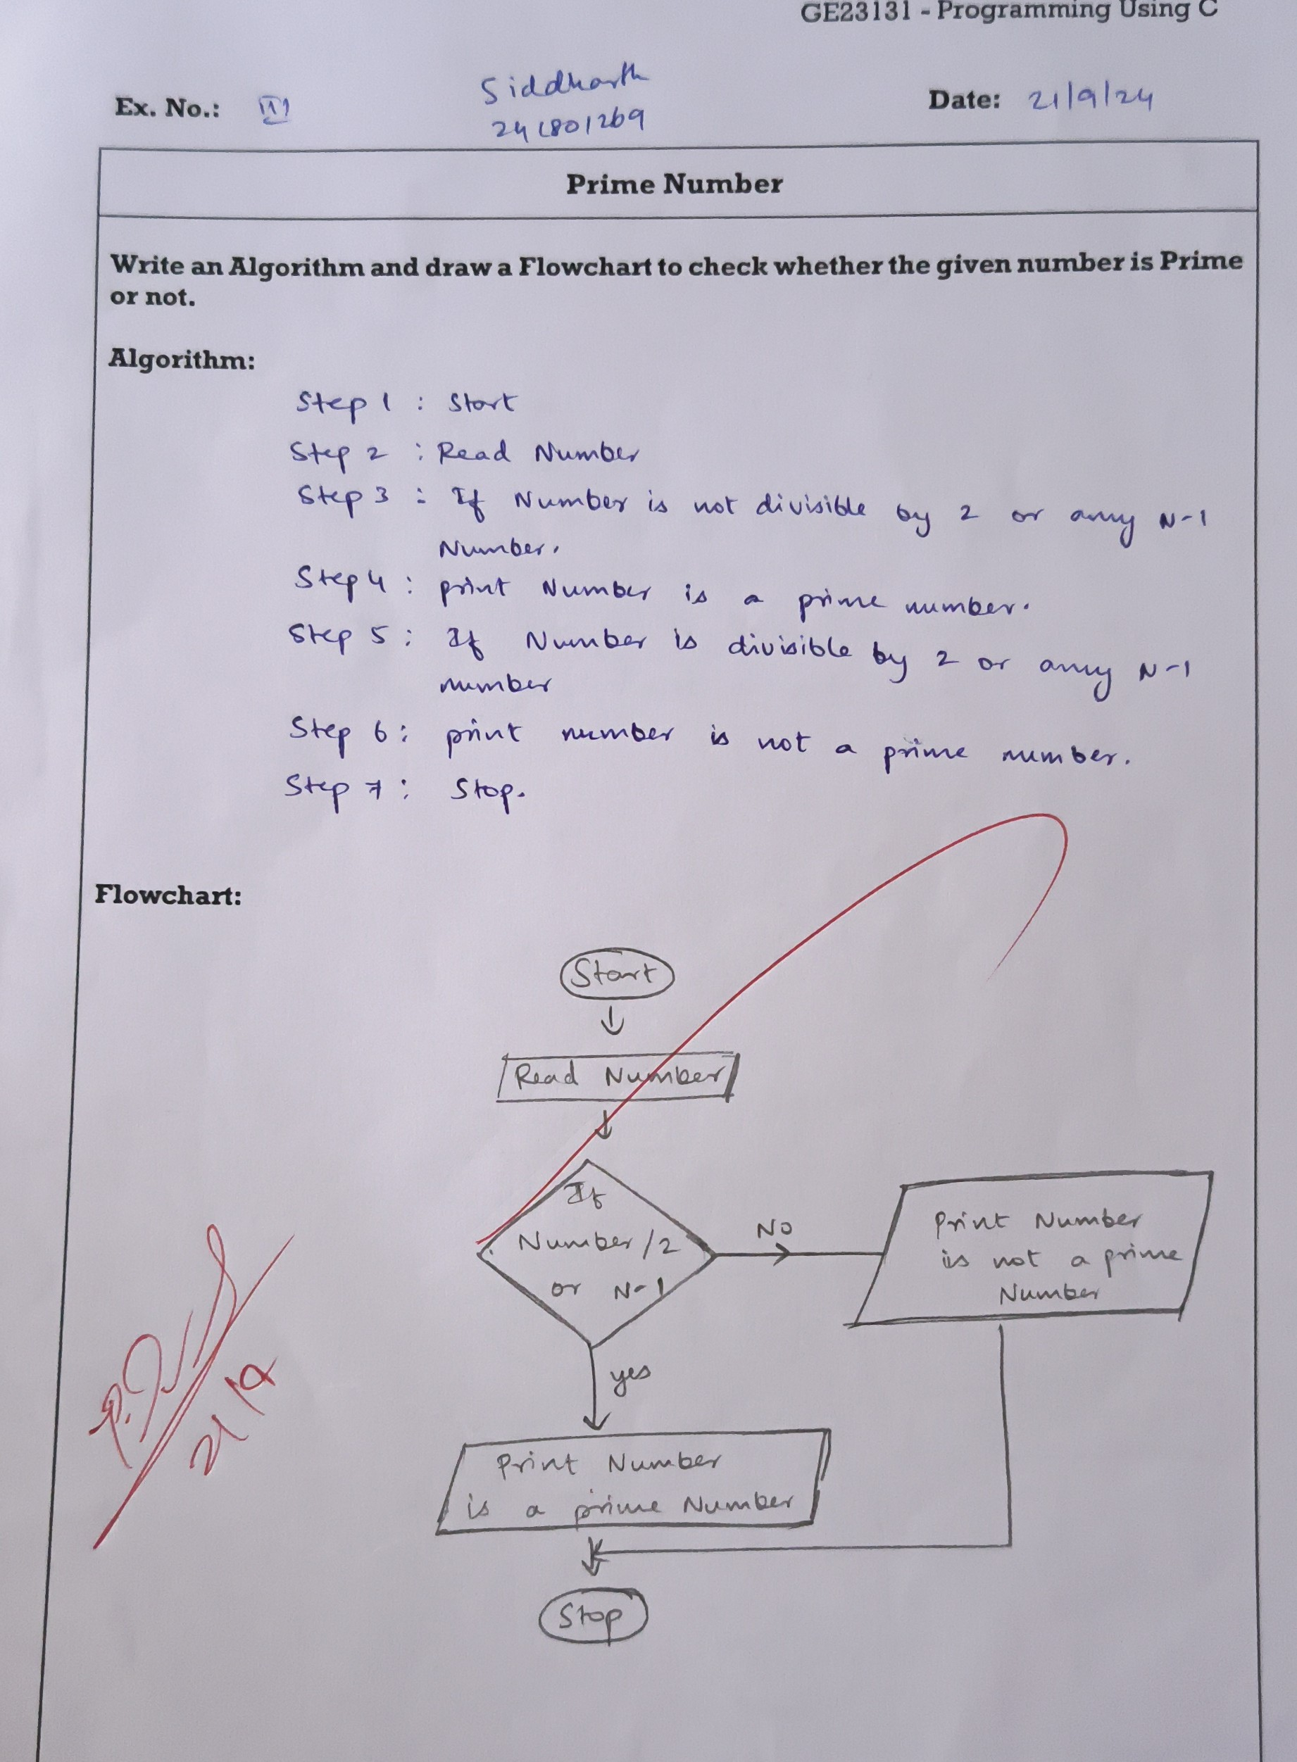
PROGRAM 03
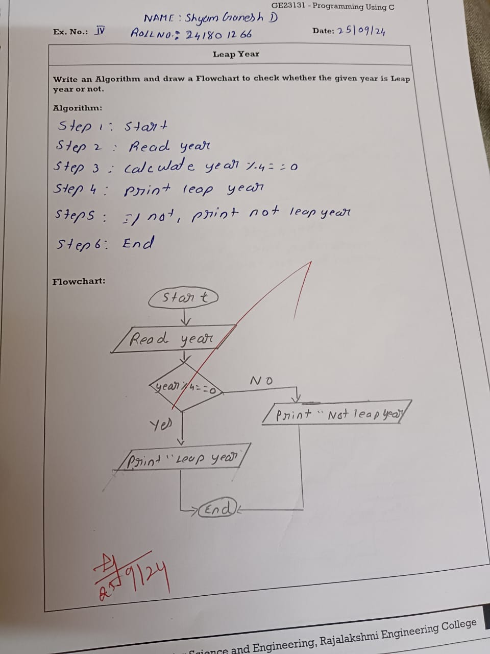
PROGRAM 04
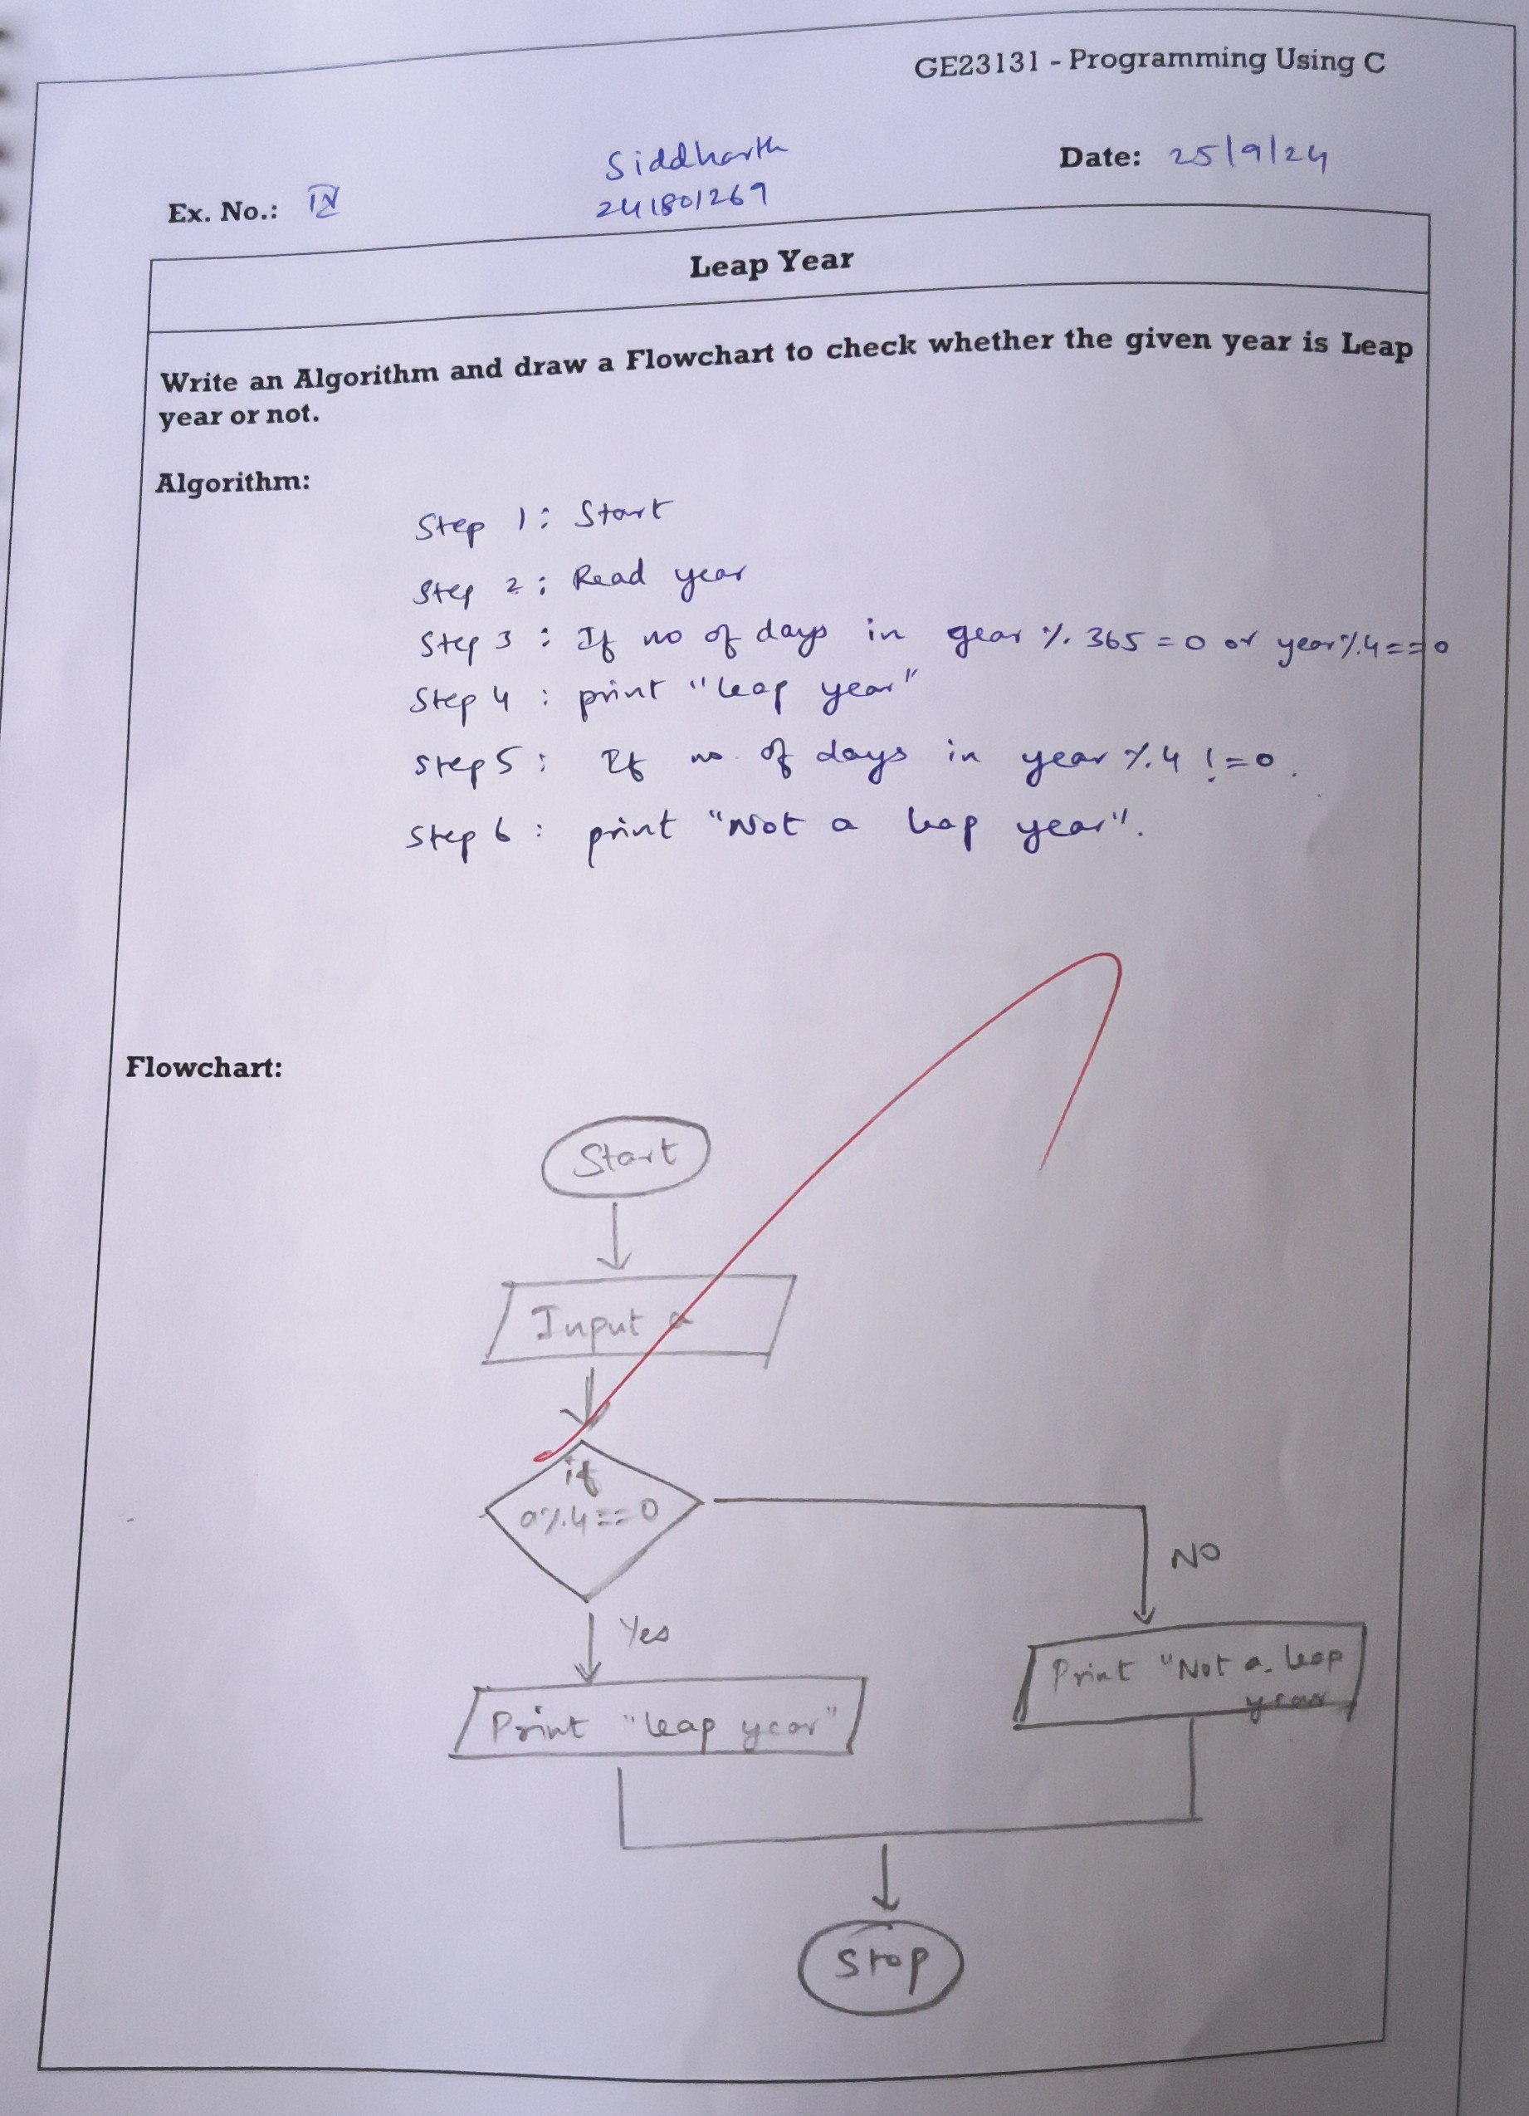
PROGRAM 05
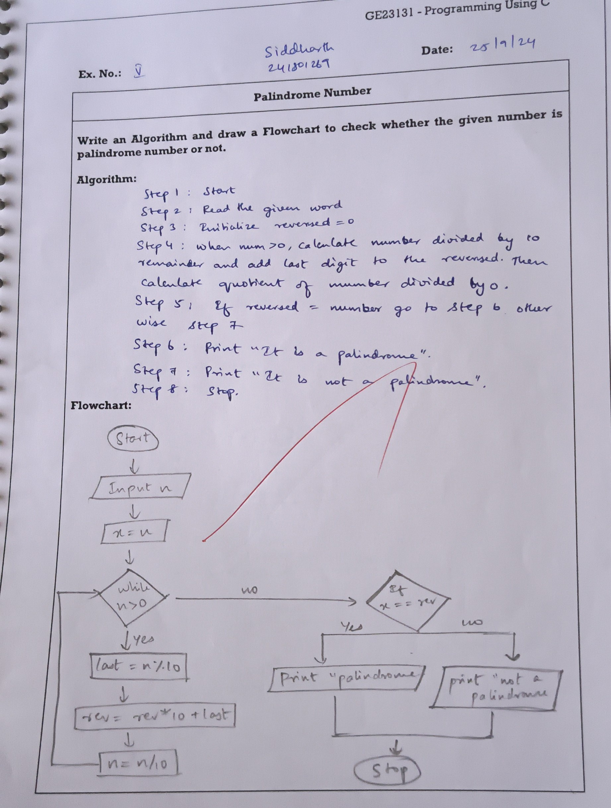
PROGRAM 06
